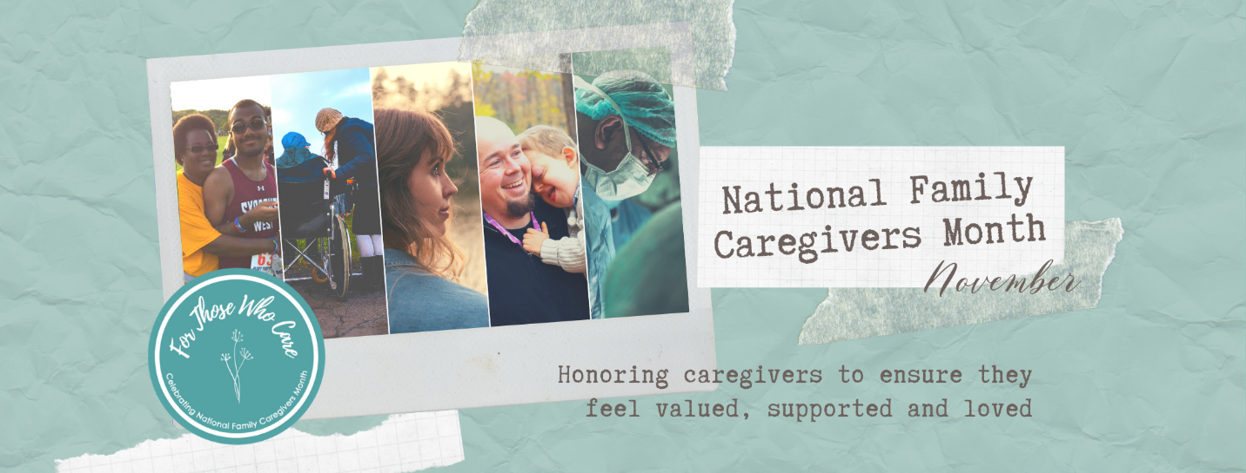

Welcome to National Family Caregivers Month 2020!

Thank you for joining this movement! Together through cohesive messaging, we will inspire our community to remember & honor caregivers, ensuring they feel valued, supported and loved.

Your media kit includes the following elements to support your organization throughout November:
- Facebook Cover Image
- Facebook Profile Picture Frame (link will be emailed 10/31)
- 2 General National Family Caregivers Month Images/Posters (print & image versions)
- 10 Social Media Posts – Language below & corresponding images attached – 10/31 introduction, two action posts per week (4 weeks), 11/30 wrap up

Social Media Posts

10/31 Introduction Post
Tomorrow kicks off our celebration of National Family Caregivers Month! In partnership with David’s Refuge, we will be sharing tips each week throughout November to help you better support the caregivers in your life. Caregivers can feel invisible - and in our current situation, more isolated than ever. Join the movement in our community to remember and honor caregivers, ensuring they feel valued, supported and loved!

Week One Theme: Write a Letter to a Caregiver

Week One, Post 1
There is nothing like an unexpected note from a friend. Being noticed and feeling remembered are two simple yet powerful experiences every human craves. We know that one of the greatest struggles for caregivers is an ongoing sense of isolation. So this week, send a handwritten note to someone, just because. Remind a caregiver that they are not alone, what they do matters, and God & this community loves them.

Week One, Post 2
Be the person who notices. The opportunities are less right now but be on the lookout for moments to encourage. At the park, stop by the boisterous family with a special needs child and tell the parent, “I think you’re doing a great job.” Offer the woman at church caring for her husband a smile or nod that say, “You’ve got this, you’re welcome here,” after he calls out during the service. Maybe they are drops in a bucket…but every drop counts when someone’s bucket is nearing empty.

Week Two Theme: Practice Self-Care - Walk, Roll, or Ride One Mile Everyday

Week Two, Post 1
Exercise is an incredible form of self-care but in times of stress, we tend to put ourselves last. Honor yourself by making a commitment to your health and wellbeing with a goal of daily activity for one week. Keep this promise to yourself and then reflect on how that makes you feel. Think of a caregiver friend who could use this challenge and share it!

Week Two, Post 2
This week, give yourself the gift of activity and relationship! According to the CDC, getting active with a partner means you will be more motivated, more adventurous, and more consistent. So make that commitment to yourself and someone you care about and be active every day this week. Go for a walk/roll/ride around the neighborhood with a caregiver friend and the whole family.

Week Three Theme: Send Some Love – Call a Caregiver or Send a Meal

Week Three, Post 1
Your phone is in your hand right now, isn’t it? Can you think of someone who needs to hear from you today? It takes 20 seconds to tell a caregiver they are doing a great job, but the feeling of being remembered…that sticks with all of us. Send an encouraging text of make a phone call right now!

Week Three, Post 2
Whether you know someone really well or hardly at all, figuring out how to support a person through the hard stuff life brings can be a challenge. Our culture loves people through food, so that is a wonderful way to participate! Make it a goal to coordinate a meal for a caregiving family you know this week. Takeout, homemade, or a gift card – so many ways you can love people through their bellies!

Week Four Theme: Practice Gratitude

Week Four, Post 1
Gratitude opens our eyes to goodness, but we have to focus. The more specific we can be with our words, the greater their power. Take a moment to stop and consider a person or moment you are grateful for. Recollect the feelings of joy. Write it down specifically so you can train your brain to see the good.

Week Four, Post 2
Sharing your gratitude multiplies its good. Who is a caregiver you are grateful for? Write a note, send an email, or send a text message sharing why you are grateful for them. You’ll both be glad you did.

11/30 Wrap Up Post
Thank you for joining us for National Family Caregivers Month! To learn more about how you can come alongside caregivers in our community, please visit davidsrefuge.org

For support or if you have any questions, please contact Kate Houck, Executive Director at kate.houck@davidsrefuge.org. Thank you for participating in National Family Caregivers Month 2020!

